**Lab 2   
REST web service documented with Swagger**

This lab will show you how you can document your Spring Boot REST web service using Swagger.

http://localhost:8090/v2/api-docs

http://localhost:8090/swagger-ui.html#/

# Starting point

The starting point for this lab is the service that was made in Lab 1. The code of this service is put in directory /home/developer/projects/SIGSpringBoot101/lab 2/dronebuzzers. .

Start by opening Eclipse 

Pay attention: go to the Ubuntu top of the window and from the menu bar click on File and then Import:

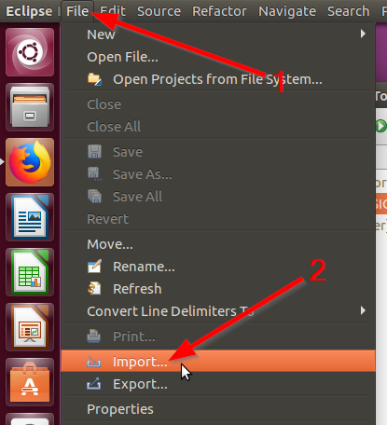

In the resulting Import pop-up, select ‘Existing Maven Projects’:

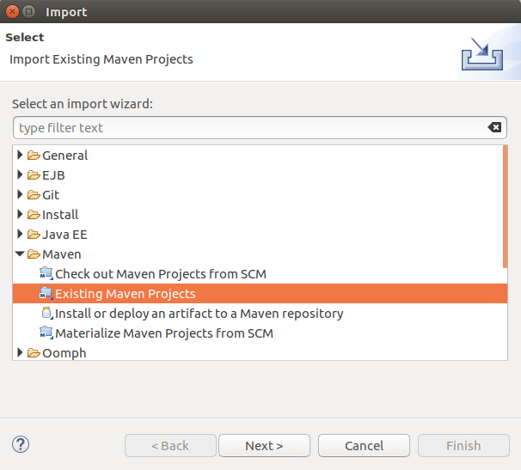

Click Next and then (1) set the Root Directory and (2) select the pom file:

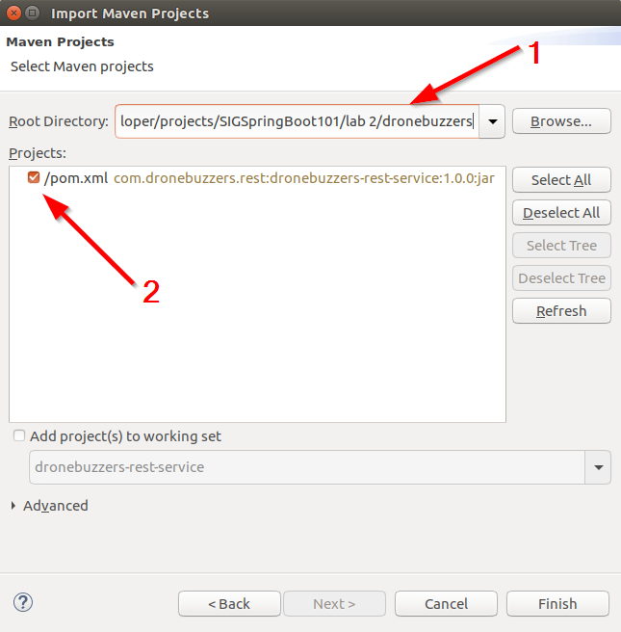

Click Finish and the dronebuzzers-rest-service project should become visible in the Package Explorer:

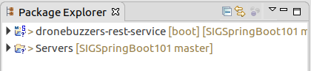

# Code changes for documentation

Adding documentation to the service is surprisingly simple:

* Step 1: add the Maven dependencies
* Step 2: add the Docket bean

**Step 1: add the Maven dependencies**

In the pom.xml file, add the dependencies that can be found in file:

/home/developer/projects/SIGSpringBoot101/lab 2/input/mvn-dependencies.xml

The pom.xml will then look like:

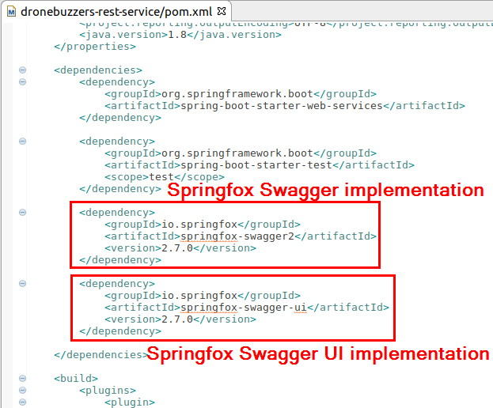

The top dependency adds the Springfox support for the Swagger specification. If only this dependency is added, a ‘machine-readable’ specification is available from the running service. The bottom dependency adda the Springfox Swagger UI implementation, for a human readable interface specification.

**Step 2: add the Docket bean**

To make the API specification/documentation available, a so-called Docket bean has to be added.

Right-click the project and add a java class:

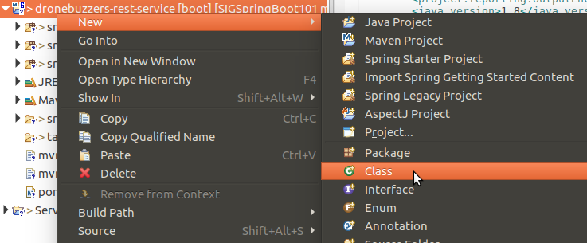

Complete the form like shown below:

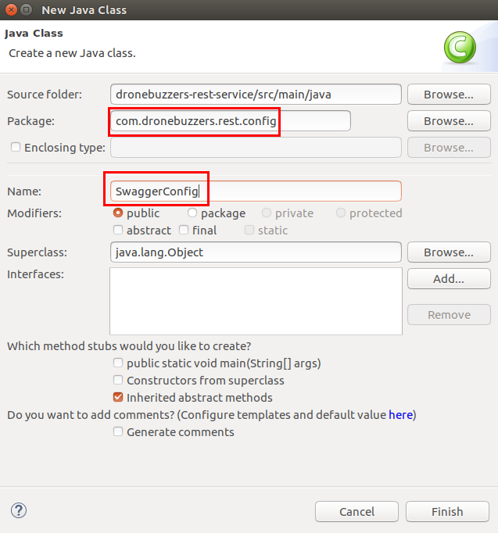

Next, replace the code of SwaggerConfig.java by the content of file:

/home/developer/projects/SIGSpringBoot101/lab 2/input/mvn-dependencies.xml

The resulting code will look like:

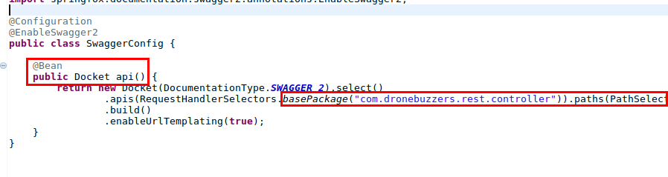

The Docker configuration identifies what to add to the interface.

# Run

Now that the code is ready, it is time to build the code: right-click the project, click ‘Run As’ and select the option ‘Maven build…’:

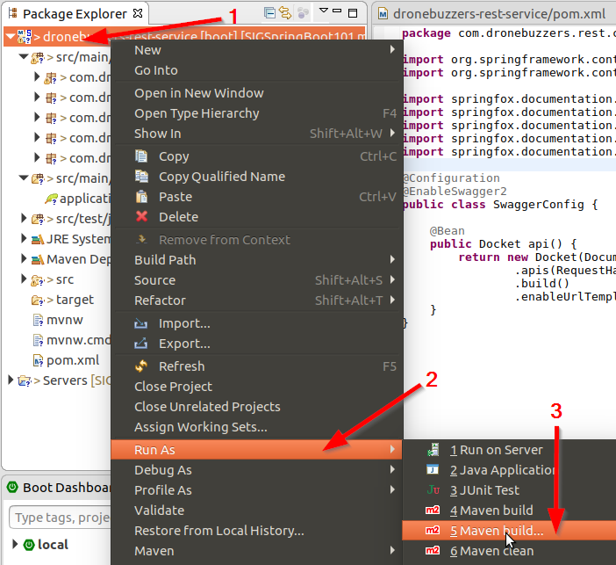

The pop-up window as shown below will be shown:

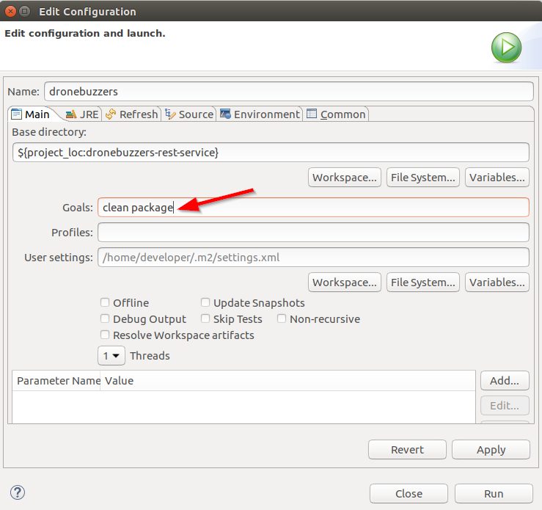

Complete like shown above and click Run. Check in the console that the code is built successfully:

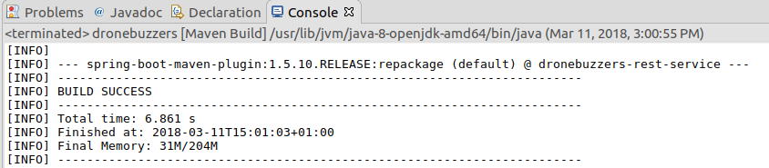

The code is built: time to run it: right-click the project, select ‘Run As’ and then ‘Spring Boot App’:

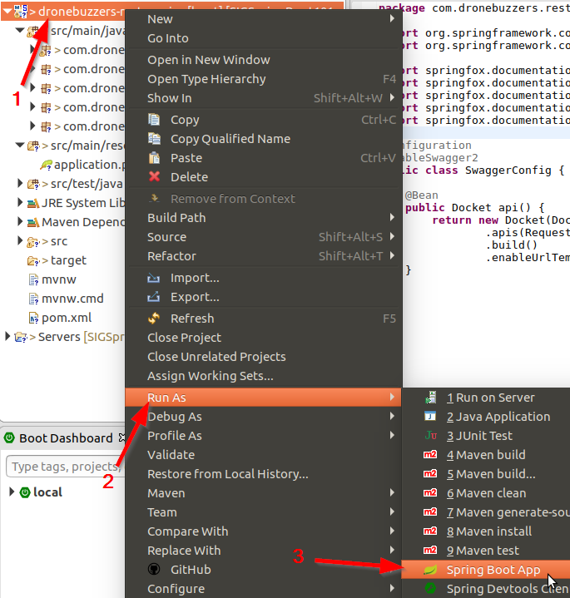

Verify the Console window for errors…

# Verify documentation

There are two Urls that are of interest.

1. Swagger API 2.0 specification document

The Url <http://localhost:8090/v2/api-docs> will return the Swagger API 2.0 specification document:

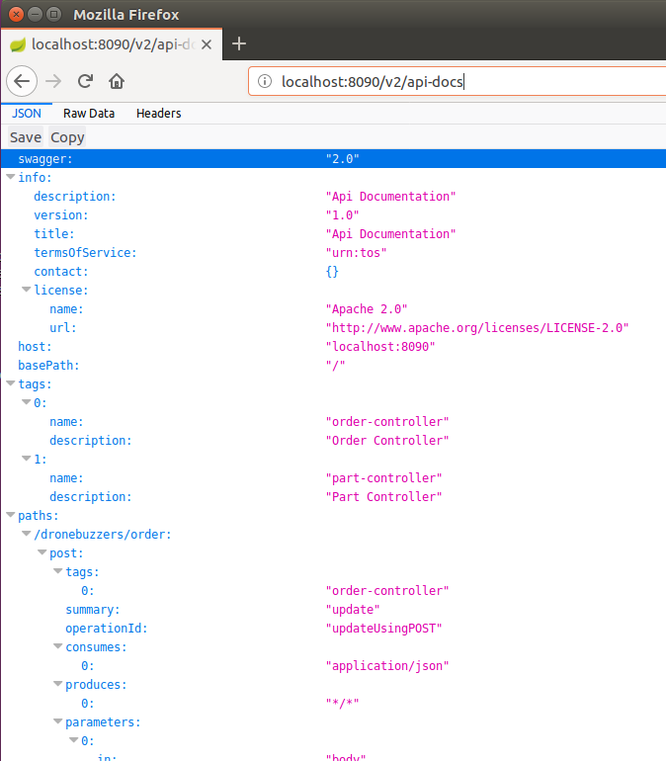

1. Human readable documentation

The Url <http://localhost:8090/swagger-ui.html> will bring you to a more human readable document format.

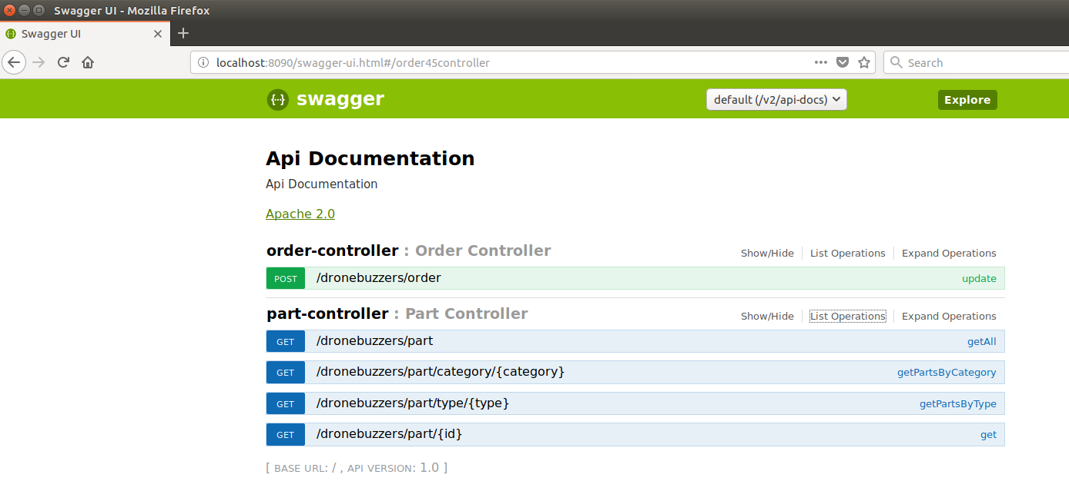

Spend some time on inspecting both urls.

# Additional pointers

* How to configure the Docket:   
  <https://springfox.github.io/springfox/docs/current/#springfox-configuration-and-demo-applications>
* How to insert additional adocumentation in the code:  
  <https://springfox.github.io/springfox/docs/current/#support-for-documentation-from-property-file-lookup>